FISO School Improvement Model

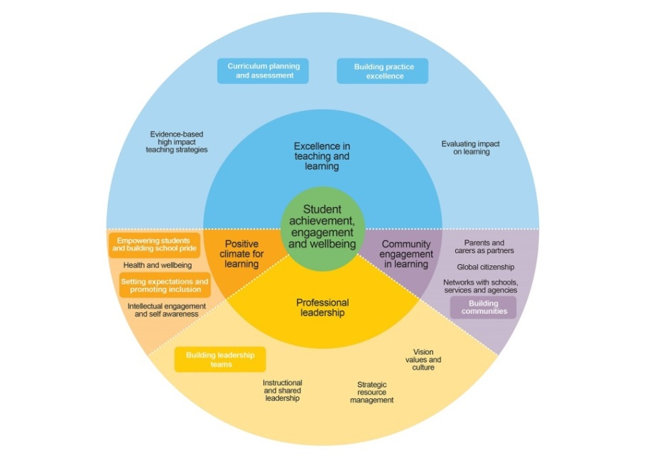

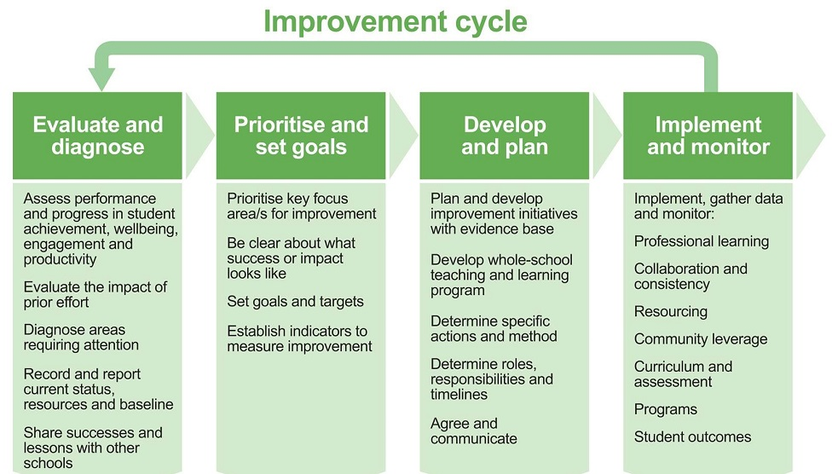

School review 2016

Strategic Planning is a 3 stage process.

Stage 1 Self evaluation completed by week 3, term 3.

At this stage of the school review process we are evaluating our progress towards achieving the goals in the 2012 – 2016 Strategic Plan.
From the Self-evaluation Report we identify 2-3 Terms of Reference for the School review to be held in term 3.

Community Activities

Wall Board for comments up in foyer, Monday July 11th – Friday, July 23rd

Community feedback forum, Wednesday July 20th 6.30 – 8.00pm

Stage 2 School Review after week 4, term 3.
2 day school review lead by Principal, School Reviewer and Challenge Partners including consultation with staff, School Council and parents.

Stage 4 Completion of the Strategic Plan 2017 -2018, term 4

