Scope:
This policy applies to all employees, students, visitors, volunteers and contractors in the Department of Education and Training (DET). This policy builds on Part 4 of the Victorian Occupational Health and Safety (OHS) Act 2004 which outlines the legal duties of employers to consult.

DET OHS Commitment and Principles:
DET is committed to providing DET workplaces with consultative arrangements that allow employees to contribute to decisions that impact on their health and safety.

DET will communicate matters affecting state-wide OHS information to internal and external stakeholders.

Consultation will not delay the implementation of a policy or procedure to address an immediate health and safety risk.

Policy Objectives:
DET is committed to:
- consulting with employees, so far as reasonably practicable on OHS issues and changes that affect their workplace including:
- identification of workplace hazards
- assessment of the risks associated with workplace activities and hazards
- decisions made to eliminate or control workplace risks
- review of workplace risk assessments
- introduction of, or alteration to, procedures for monitoring workplace risks
- decisions made in relation the adequacy of workplace facilities
- proposed changes to the work premises, systems of work, plant or substances used at the workplace
- decisions about changes in job role
- decisions about consultation procedures, and any legislative requirements.
- providing access to specialist health and safety advice and services to DET employees, where health and safety issues cannot be resolved directly as a result of using the local/established health and safety issue resolution procedure.

DET employees, visitors, volunteers and contractors are required to:
- consult and cooperate with DET on OHS related matters
- openly communicate any instances of hazards or incidents in the workplace
- provide feedback to DET on the effectiveness of established consultation and communication arrangements.

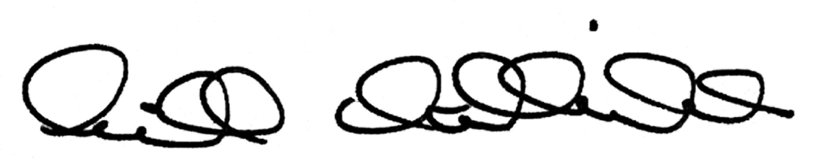
Gill Callister
Secretary
5/5/2015

